2020

Arlo Steyn

Space Attack

6/2/2020

IT PAT Phase 1

[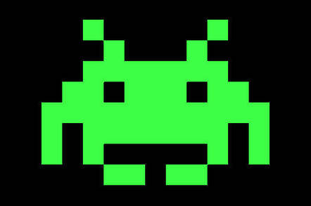](https://www.google.co.za/url?sa=i&url=https%3A%2F%2Fwww.theregister.co.uk%2F2013%2F06%2F05%2Ffeature_space_invaders_at_35%2F&psig=AOvVaw256f76EjkcZj6WaJkHGXQi&ust=1581061231036000&source=images&cd=vfe&ved=0CAIQjRxqFwoTCNiWoaq2vOcCFQAAAAAdAAAAABAE)

**Summary of Task:**

Space Attack is a two-dimensional shooter game. Space Attack is definitely not a copy of Space Invaders. The game will be set in space just outside earth’s atmosphere, you will play as a spaceship that can move left or right in a fixed position at the bottom of the game. Rows of “Aliens” will attack you by slowly moving towards you (spaceship) and the earth. You will shoot down these aliens and gain a score. The aliens as well as spaceship will have the ability to shoot in a straight line. As the game progress’s, the aliens will slowly advance whilst more rows of aliens will appear. If you do not shoot down the aliens in time (If they reach the earth) or if they shoot you down, the game will end and provide you with a high score. The game will get progressively harder, a scoring and time system will be provided to determine the high score. The aim of this game is to challenge yourself or friends to see who will get the highest score.

**Specifications of Program Functions**

The function of this program/game will be for leisure purposes.

* User will be able to write their name that will be stored with their score.
* User will be able to move left and right on a fixed axis whilst also being able to shoot projectiles at the AI.
* A timer will be allocated during the duration of the game time.
* A score will be provided based on AI destroyed and time survived.
* Power ups will be provided in intervals of time to assist the user while playing the game.
* The “Aliens”/AI will be able shoot back at the user as well as move down the screen towards the user.
* More and more rows of AI will be added as the game progresses.
* A health bar will be provided to the user, when this health depletes, the game will end.
* A list of the high scores (With the username) will be provided after the game as well as in a separate menu.

**Specifications of User Interface**

A “start” screen will be provided once the game is first loaded, once the “start” button is pressed, the user will be taken to the home/menu screen. This screen can take the user to the following screens: The game screen where the game will be played, the help/tutorial screen which will assist the user in playing the game by giving instructions and a help function will be added to assist the user if they come across any problems, a score screen which will show all previous and current scores recorded with the username of the user that made the score. These scores will be ranked from best to last. In the game screen the user will be provided with an in-game timer as well as score and health bar system. The overall user interface of this program will be user-friendly, easy to use and well made (look nice).

**Specifications of Help**

Space Attack is a relatively simple game, however an in game manual/tutorial will be provided in the menu screen to assist the user. This manual will consist of a “controls” section and an “interface” section. The “control” section will provide the user with the allocated controls used to play the game, such as; moving left or right, a shooting button, a power up button. The ‘interface’ section will show the user the basic layout of the game by providing the user with the layout and pointing out what everything does with an explanation. An instructions screen will also be provided, providing the purpose of the game to the user. Lastly, a help screen will be provided for the user if he/she experiences any problems in the game or interface. An email will be provided to contact the developer’s assistant and or the developer. All of the above screens will be easily accessible for the user in the main menu screen.

**Specifications of Data Storage**

The Following Data will be stored:

* User/Player Name as a String value
* High score as an Integer Value

These will be stored and accessed in a text file so that the data can be read and interpreted.

**Hardware and Software Requirements**

Hardware:

* Processor: 1 gigahertz (GHz) or faster processor or SoC.
* RAM: 1 gigabyte (GB) for 32-bit or 2 GB for 64-bit.
* Hard disk space: 16 GB for 32-bit OS 20 GB for 64-bit OS.
* Graphics card: DirectX 9 or later with WDDM 1.0 driver.
* Display: 800x600

Software:

* Minimum Windows 10 will be required to access these programs and functions.
* Java Runtime Environment(JRE) 8.2